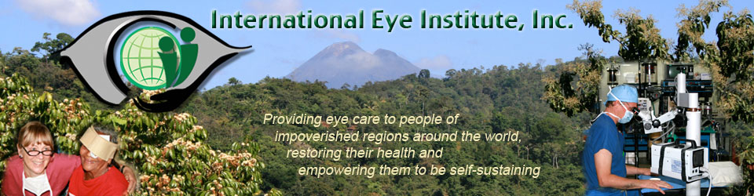

December 8, 2017

Dear Friends,

The volunteers and supporters of the International Eye Institute continue to amaze me! Your undying commitment to those in need of eye care continued throughout 2017. In addition to our annual surgical teams’ commitments in Honduras and Guatemala, we offered surgery in Peru this year. A team of intrepid adventurers travelled the winding roads in the Andean highlands of Peru. We worked with the staff of a small hospital in the town of Lircay, nestled in a deep valley at 10,750 ft with towering peaks all around. The people of this town had never seen an eye surgeon. Their operating room was clean with autoclaves for sterilization, running water, electricity. They had everything we needed in a facility. We brought a microscope, all the surgical instruments, supplies and medications that we would need. We also had the pleasure of including on our team two ophthalmology residents from Lima, a Peruvian ophthalmologist and a Peruvian optometrist from towns in nearby regions.

It is often the case that as a new medical/surgical team we are greeted by the locals with a degree of skepticism. They have had no prior experience with us and I understand are often wary of subjecting themselves to eye surgery. So the ones who come forward are often those who are the worst off with blindness or bad injuries or infections.

Still we saw 250 patients in the clinic and did 16 surgeries, some under general anesthesia. Not a bad turnout for our pilot project. The Peruvian American Medical Society coordinated our stay and was very helpful in negotiating the inevitable bumps along the way in setting up any new project. Importantly, they would like us to return. So we will be looking at options in the next year or two.

The surgical teams to Guatemala and Honduras continue to work with the local health providers there. We are happy we were able to see 775 patients in clinic and perform 149 surgeries during the year. This included the first corneal transplants ever performed at Hospitalito in Guatemala by Dr. Shah.

Of course we wouldn’t be able to do this work without your support. We’d love it, and our patients will be most grateful if you would continue (or begin!) your contributions to our international eye projects. These patients literally would not be able to see an eye doctor if we didn’t come. Some of them wouldn’t be able to see at all…

Have a wonderful holiday season and I hope 2018 brings you great joy.

Sincerely,

Justin StormoGipson, MD

**1814 Lincoln Way Coeur d’Alene, Idaho 83814 T. 208-665-2255** [**info@eyegive.org**](mailto:info@eyegive.org)

[**www.eyegive.org**](http://www.eyegive.org)

International Eye institute, Inc. is a 501(c)3 Non-Profit Corporation EIN 32--249964